

Internet of things lab ASSIGNMENT

Course code: CSE-402

Submitted to:

Ayanava Paul

Lecturer, UITS



Submitted By:

Md. Shakibul Islam Ramim

ID: 2125051063

Batch: CSE-50

Section: 7B1

Email: 2125051063@uits.edu.bd

## **Temperature and Ultrasonic Sensor**

### Circuit Figure:

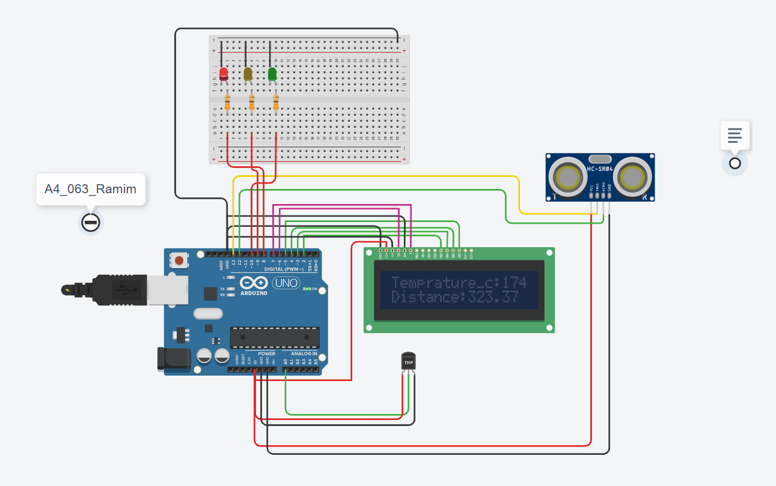

### Code:

#include <LiquidCrystal.h>

char temp[] ="Temprature_c:";

char dist[] = "Distance: ";

int trigPin=13;

int echoPin=12;

int ledPin[] = {8,9,10};

int pinCount = 3;

LiquidCrystal lcd(6,7,2,3,4,5); // Rs, E, D4, D5 D6, D7

void setup()

{

pinMode(A0,INPUT);

pinMode(trigPin, OUTPUT);

pinMode(echoPin, INPUT);

for(int i=0;i<pinCount;i++){

pinMode(ledPin[i], OUTPUT);

}

lcd.begin(16,2);

Serial.begin(9600);

delay(1000);

}

void loop()

{

//temp

int sensorValue = analogRead(A0);

float mV=(sensorValue/1023.0)*5000;

int tempCel=mV/10;

Serial.println(tempCel);

//distance

digitalWrite(trigPin, LOW);

delayMicroseconds(2);

digitalWrite(trigPin, HIGH);

delayMicroseconds(10);

digitalWrite(trigPin, LOW);

long duration = pulseIn(echoPin, HIGH);

float distance = (0.0332*duration)/2;

//led

if(tempCel >= 75 && distance >= 175){

digitalWrite(ledPin[0], HIGH);

delay(1000);

digitalWrite(ledPin[0], LOW);

}else if(tempCel >= 50 && distance >= 150){

digitalWrite(ledPin[1], HIGH);

delay(1000);

digitalWrite(ledPin[1], LOW);

}else{

digitalWrite(ledPin[2], HIGH);

delay(1000);

digitalWrite(ledPin[2], LOW);

}

lcd.setCursor(0,0);

lcd.print(temp);

lcd.setCursor(13,0);

lcd.print(tempCel);

Serial.println(temp);

lcd.setCursor(0,1);

lcd.print(dist);

lcd.setCursor(9,1);

lcd.print(distance);

Serial.println(distance);

delay(2000);

}

The End